**Form Design**

**Project Title:** ADMINISTRATIONE ECCLESIAE

Form1: Home page of admin.

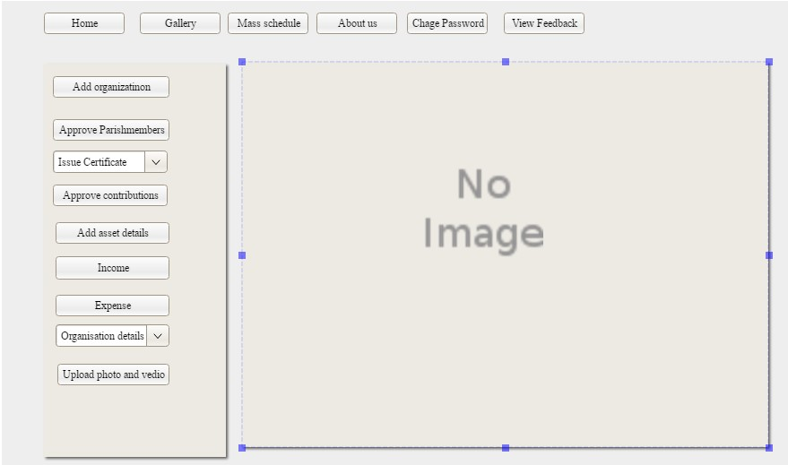

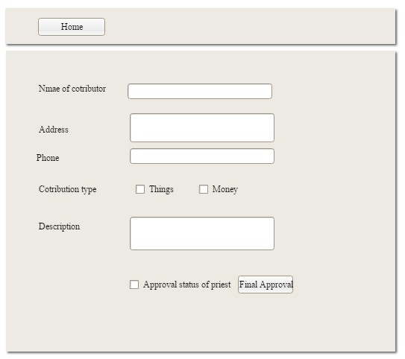

Form2: Approval of contribution by admin.

Form3: Add income types.

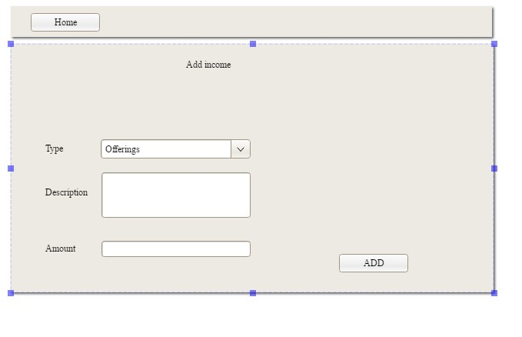

form4: Add organization.

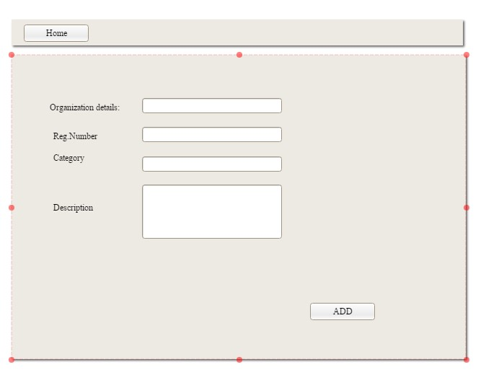

Form5: Add asset details.

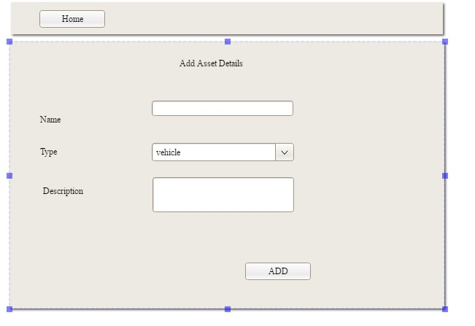

Form6: Add event details.

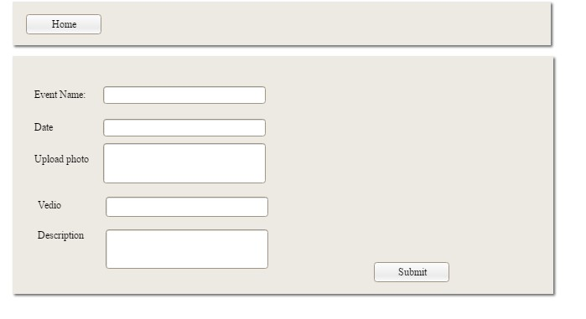

Form7: Add and approve members to organization.

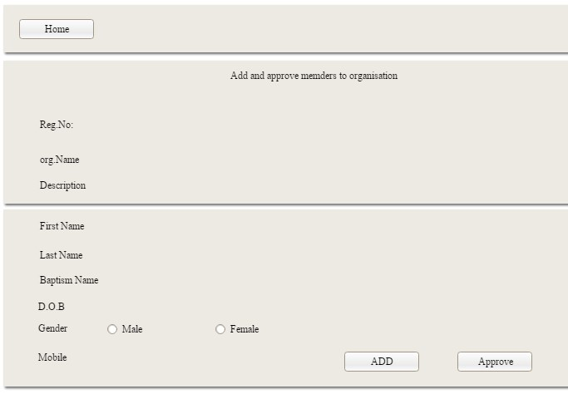

Form8: Home page of priest

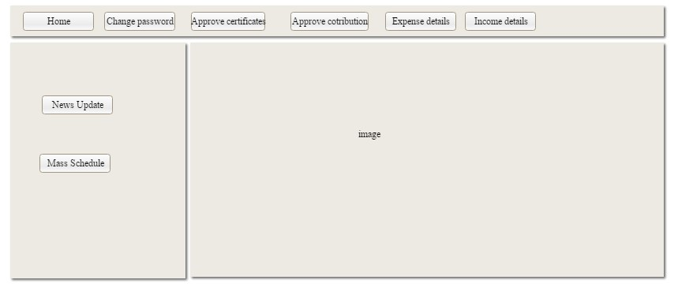

Form9: Add Mass schedule.

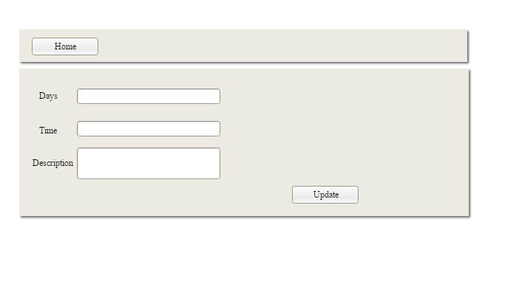

Form10: Home page of parish member

